|  |
| --- |
|  |
| **COMP 8045 PRACTICUM PROPOSAL** |
| **BCIT Bachelor of Technology Program Database Specialization** |
|  |
| **Yasheng Xue (A00681622)** |
|  |

|  |
| --- |
|  |

Table of Contents

Student Experience 2

Project Background 3

Nature Problem 3

Project Description 3

Employee Information Management 4

Customer Maintain 5

Project Maintain 6

Generating Report 6

Department Maintain 7

Roles 8

Administrator 8

Team Leader 8

Employee 9

System 9

Database Design 10

RDBMS 10

Nosql 12

Methodology 13

Technical complexity Enhancement and New Leading edge Technology 13

Scope and depth 16

Test Case 17

Time Estimates 20

Appendix 21

Change Log 23

# 

# Student Experience

**YASHENG XUE**

1004-4288 Grange St xueyasheng@gmail.com  
Burnaby, BC, V5H 1P2 778-991-1665

**Skills**

Recognized ability to communicate with people

Accept supervision willingly, friendly, and social

Quick study, responsible, punctual and be able to work well independently or in a team

Ability to solve simple computer problems and install operating systems

**Technical Proficiency**

Operating System: Linux, Windows 98/XP/Vista/7

Languages: SQL, Asp.net, HTML, JavaScript, Java, C++, PHP

Database Environment: Oracle RDBMS, Oracle WB, Oracle ODBMS

Experience with AutoCAD

**Work Experience**

**Computer Technician, Customer Service** (summer, 2011) Computer Express Repair CenterRichmond, BC

**Education**

British Columbia Institute of Technology, Burnaby, BC (2010-Present)   
Bachelors of Computer Systems Technology

British Columbia Institute of Technology, Burnaby, BC (2009-2010)   
International Student Entry Program

Project Background   
My project sponsor is Beijing Suplus Technologies Co. Ltd, which aims to China Enterprise Communications and application market, dedicated to the development and promotion of new technologies, new products. During the time, Suplus Technologies has helped China Unicom, China Mobile, China Telecom, and Jinjiang Inn to build call center system. Meanwhile, Suplus Technologies has worked with Avaya, IBM, and Cisco on several projects during the years.

Here is Suplus’s website <http://www.suplus.com.cn/index.jsp>. And my supervisor Mr.Jiang’s email addresses: jiangxin@suplus.com.cn.

# Nature Problem

According to the background, Suplus Technology focuses on providing call center system for some corporations as Suplus’s customers. As long as customer decides to work with Suplus, there is a project created. Meanwhile, Development department is going to work on system design, Finance department is going to make budget. But Suplus has couple locations in China and each location may work on several projects. Therefore, Suplus requires a system to manage information and make sure the each location work efficiently.

As an intern of Suplus Technologies, there is an office management system required to be accomplish. This office management system focus on tracking information such as employee information, customer information, project information, generate report of each project as necessary time( such as every 2 weeks).

# Project Description

This practicum project is to develop a system to manage and organize information of Suplus Technologies, and it could track activities as well. The system could provide functions which are Employee Maintain, Project Maintain, Customer Maintain, Generating Report, and Department Maintain.

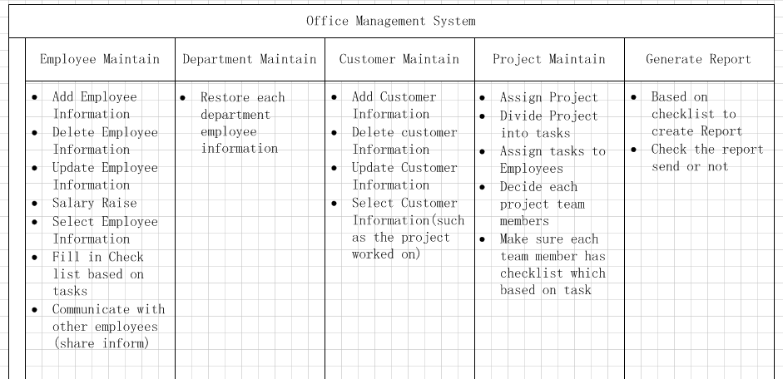

## Employee Information Management

The purpose of Employee Information Management is to help organise employee’s information better. Suplus has 3 locations in China; each location has different employees, customers and projects. Employee management could store employee’s information organised, and easy to update as well. The functions of Employee Information Management include:

* Add, Update, Delete employee information

If there is a new employee join Suplus, the new employee could register an account on the system. The administrator should add information (name, ID, Employee ID, Birthday, Department, and Salary) to this new employee.

When employee gets promotion, move to other department or any information has been changed, administrator should update information as soon as possible. If an employee resign or couldn’t work for Suplus any more, information should be deleted.

* Salary Raise

When an employee gets promotion, the salary should be higher than before. Therefore, the stored salary information should be changed.

* Fill in check list based on the task

When Suplus gets a project, team leader will divide it into several tasks and assign them to employees. At the same time, team leader will create check list which is a task time estimate for team members who are working on this project. Employees who are assigned to the project have responsibility to fill in check list, because the check list is most important data to generate report.

* Communication   
  There is an Employee Communication page that adapts waterfall layout. Employee could share idea (picture, video) on this page, and other employees can comment on it. Instead of instant message, employee could share idea that may inspire other co-workers. At the same time, the waterfall style layout similar as Facebook, Google+ social website, it could active office environment.



## Customer Maintain

Suplus Technologies has been worked with many customers, organizations and companies, which are very important clients. Record customer information could help Suplus to maintain product and track feedback better. Therefore, Customer Maintenance is a significant function in the whole system. This function could build a steady and safe customer information database, and easy for administrator to search customer’s information.

* Add, Update, Delete customer information  
  when a new customer work with Suplus, it generate a new customer ID and add customer basic information (customer name, customer ID, customer phone number, customer Address, project ID) to system.   
  If the stored customer information has changed, such as phone number or address changed, the information should be updated as well.   
  If a recorded customer or company disable to work with Suplus because bankrupt or cancel project, then customer information could deleted.
* Select customer information  
  If require a customer information, system should allow employee or administrator to retrieve it.

## Project Maintain

Because Suplus has been worked with many organizations and companies, there have same amount projects as well. Some project is built on the previous projects, so it requires a functional management method to organize these projects as well. As long as system accomplished, it could help maintain all Suplus projects and keep them in order.

* Assign Project  
  when a customer sign the contract with Suplus, there is a new project should be inserting into the project table, which includes Project_ID, Project_name, Customer_ID, Project_status, Project_leader, Employee_ID，payment_status，Contract_ID. At the same time, development department decides a team leader will in charge this project during the development.
* Divide Project into tasks  
  the first job of team leader is to divide current project into small tasks. It is easier to monitor project process and follow schedule. After this step, the project becomes to considerable tasks.
* Assign tasks to employee/team member   
  when the tasks are ready, team leader should work on decide team members who are going to work on this project in the future. These team members will assigned to the tasks has been divided. At the result, each team member (most are development department employee) has at least one task.
* Make sure each team member has checklist which based on task  
  after team leader assign tasks to team members, team leader should decide the deadline of each task, and the deadline is based on project schedule. The checklist will display on team member personal page, and then team member could check tasks process. For example, the checklist shows which task has accomplished, and which are processing now, and the deadline of the processing one. Every day, checklist tells team member the duty of today, and the processing task’s end date. Fill in the check list to tell did you finish toady’s job, it could help team leader to control and manage time and process better.

## Generating Report

Suplus has several locations in China now, and the head office requires all the location to hand in processing report of current project. Suplus cares and values each customer feedback and idea. For customer to know the process and status better, the system will generate a report for customer and project team leader every two weeks. At the end of month, there is a monthly report. For the project works longer than 3 months, the system will create seasonal report to inform customer and team leader about the project progress. When the project accomplished, there is a final report to customer.

* Based on checklist to create report  
  after team members fill in the checklist, system will generate a report based on check list of last 2 weeks. The report demonstrates what did the team do in the last 2 weeks, and this report will send to customer by email.
* Check the report sends or not  
  after the email sent, team leader should check the report send or not on next day. If the email did not send, team leader ought to send it to customer, and fix it.

## Department Maintain

* Restore each department employees information   
  Suplus has Development department, Administration department, Human Recourse department and Finance Department. Each department restores their employees’ information.

# 

# Roles

In order to explain how this office management works, there is a use case diagram which includes 4 different types of roles in the system**.**

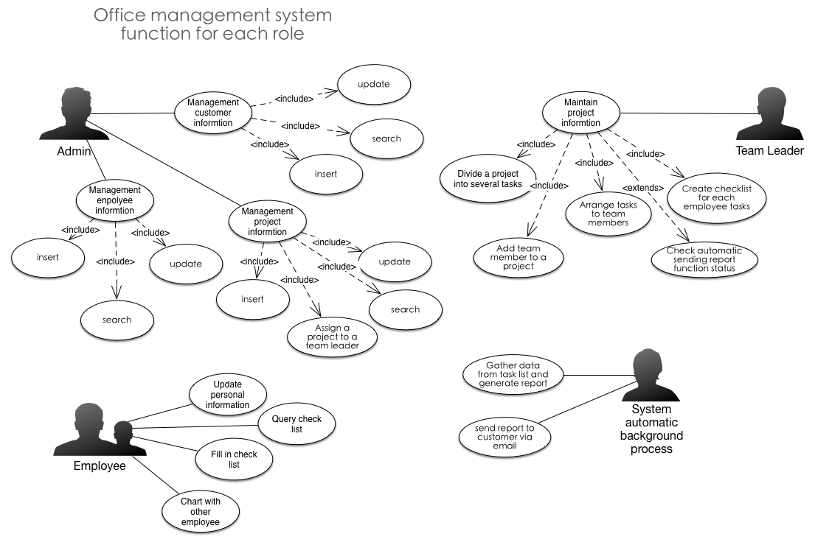

## Administrator

* Insert, update, select and delete customer information
* Insert, update, select and delete employee information
* Insert, update, select and delete project information
* Assign a project to a team leader   
  when a customer assign a contract with Suplus, Administrator should assign this project to a team leader who is working in development department.

## Team Leader

* Divide each project into several tasks

Each Project has many functions should be accomplished, and it could take at least couple months.   
Divide project into some tasks, firstly, these tasks make sure each team member clear personal responsibility in the project. Second it could help team member to fill every day check list, which is the most important part to generate report.

* Create check list for each team member based on task

Check list shows team member the duty and job should be accomplished every day. Checklist shows which task has accomplished, and which are processing now, and the deadline of the processing one. Every day, checklist tells team member the duty of today, and the processing task’s end date. Therefore, team leader should create check list to team member and make sure they will follow schedule.

* Check report sending status   
  as mentioned before, the purpose of checklist it to collect project working process and finally generate report to customers. When system sends the generated report, team leader should check the report send or not on next day. If system fails to send report, team leader should send it again.

## Employee

* Update personal information  
  Employee has right to update their personal information such as age, phone number, address.
* Fill in check list  
  Employees should fill in the check list as long as work in a project and find the check list on their personal page. If the employee who is not working on a project or not work in development department, there is no check list need to fill in.
* Communicate with other employee   
  as mentioned before, there is a water fall layout page designed in this system. Employees could share ideas, pictures, and videos.

## System

* Gather data from check list and generate report   
  Every 2 weeks, system will gather each project’s check list data, and based on these data, collect what has been accomplished in last 2 weeks. According to the data, and generate a report to customer to inform the process.
* Send report to customer   
  when the system generates the report, system should send it to customer by email.

# **Database Design**

## RDBMS

Office management system requires 6 tables, which are employee, customer, project, task, department, and report.

* Employee  
  Employee table keeps Suplus employee’s information. Employee table contains:

|  |  |  |
| --- | --- | --- |
| Name | Data type | Description |
| Name | Char | Employee Name |
| ID | Char | ID |
| Employee_ID | Char | Primary key |
| Gender | Char | Employee’s gender |
| Birthday | Date | Employee’s birthday |
| Address | Char | Employee’s address |
| Password | Char | Log in password |
| SIN | Char | Social insurance number |
| Salary | Char | Employee’s salary |
| Bonus | Char | Employee’s bonus |
| Status | Char | Position in Suplus, Admin, Leader, manager |
| Department | Char | Working department |

* Customer  
  Customer table includes customer’s information, which is:

|  |  |  |
| --- | --- | --- |
| Name | Data type | Description |
| Customer_name | Char | Customer’s name |
| Customer_ID | Char | Primary key |
| Cusomter_ phone | Char | Phone number |
| Customer_address | Char | Customer’s address |
| Payment_status | Char | There are 3 times payment on each project(beginning, middle, the end ) |
| Project_ID | Char | Foreign key |

* Project   
  Project table contains the whole Suplus’s project.

|  |  |  |
| --- | --- | --- |
| Name | Data type | Description |
| Project_name | Char | Name of project |
| Project_ID | Char | Primary key |
| Customer_ID | Char | Foreign key |
| Project_status | Char | Beginning, middle, the end |
| Team_leader_ID | Char | Team leader’s ID |
| Team_member_ID | Char | Team member’s ID |
| Project_payment_status | Char | Beginning, middle, the end |

* Task  
  each project divides into several tasks. Each task has information to store, and this information will help to create check list and report later.

|  |  |  |
| --- | --- | --- |
| Name | Data type | Description |
| Task_name | Char | Name of task |
| Task_ID | Char | Primary key |
| Project_ID | Char | Foreign key |
| Task_employee­_Id | Char | Work on this task employee’ ID |
| Task_employee_name | Char | Employee who work on this task |
| Status | Char | Task accomplished or not |
| Memo | Char | Additional information |

* Department  
  department table has following information:

|  |  |  |
| --- | --- | --- |
| Name | Data type | Description |
| Department_name | Char | Name of department |
| Department_ID | Char | Primary key |
| Employee_ID | Char | Foreign key |
| Employee_name | Char | Name of employee name |
| Project_ID | Char | Foreign key |

* Report  
  Because employee fills in check list every day, and every 2 weeks system can gather these data to generate report that includes:

|  |  |  |
| --- | --- | --- |
| Name | Data type | Description |
| Report_ID | Char | Primary key |
| Project_ID | Char | Foreign key |
| Report_status | Char | Send or not |

## Nosql

In order to add more technical complexity, this project contains 2 databases. The first one is **traditional RDBMS** as mentioned above. The second one is **Nosql** database. Thanks to **mysql cluster** enables user to using RDMBS and Nosql technology as the same time.

Currently, media websites such as Facebook, Twitter are using big data, so it plays a significant role in current database area. As mentioned before, employee communication page is created familiar with popular social media website. Although this communication page couldn't compare with Facebook on the huge amount of data, it is good to try something new technology on this project such as Nosql. Therefore, this project conducts Nosql database when develop employee communication page.   
  
Here adapts MongoDB -document-oriented Nosql database as maojor consideration. The information of communication page will be stored in a created document. The reason of using MongoDB is:

* Loading Balance: could run over multiple servers and balancing the load and/or duplicating data to keep the system up and running in case of hardware failure
* File storage: there is a function called GridFS which included in MongoDB. Instead of storing a file in a single document, GridFS divides a file into parts, or chunks, and stores each of those chunks as a separate document

At the same time, it uses mysql cluster to balance RDBMS and Nosql. The more information and technology will discuss on the Technical complexity Enhancement and New Leading edge Technology of page of 16.

# **Methodology**

The purpose of this office management system is to help Suplus’s employee work efficiently. Suplus’s employees as external users, and they rely on this system to manage their daily job. In another words, office management system should satisfy user’s requirement. Prototype methodology is based on the basic requirement to generate initial mock-ups. Therefore, prototype methodology could provide better design based on user’s functional requirement.

As mentioned before, prototype could offer a system that totally follow user’s requirement. According to prototype methodology, this office management system should follow:

1. Identify basic requirement  
   According to different role’s requirement, decide basic generous functions and make a function list. However, it should not be very detailed.
2. Develop initial prototype  
   Based on previous requirement, it should generate an initial prototype that requires Dreamweaver to create the original user interface. These mock-ups are very important, because they are the original framework of this system. In the plan, the end user (employee of Suplus) could examine the prototype mock-ups when the original html user interface accomplished. But if they couldn’t help experience these mock-ups, I would find other volunteers to experience them. This step is to make sure major functions are accomplished, which means end user should be comfortable to work on it. Collect the feedback and new ideas as long as need.
3. Enhance the prototype  
   Gather together the feedback, the prototype should be improved. During this step, start to program the system based on the previous prototype by using php, Nosql and mysql to build database.
4. Test  
   Test case is always the most important step when developing a system. When the system accomplished, make sure there has a plenty time to test these functions by follow the test case. For the detail, please check test plan part.

# **Technical complexity Enhancement and New Leading edge Technology**

As stated before, this online office management system is using php as major web programing language, and mysql and nosql as database. In other word, there are 2 different kind of database in this project.

However, in order to enhance technical complexity, office management system considers adapting following technologies:

* Mysql cluster (New Technology)

Because mysql cluster enables users to mix relational and Nosql technologies, this project will install mysql cluster to make sure traditional RDBMS and Nosql work concurrently. And this is new technology conducted in this project too. The advantages of mysql cluster are:

1. Concurrent NoSQL and SQL access to the database;
2. Simple multi-master replication with automated failover and recovery within and across data centers;
3. Auto-sharding and scale-out across commodity hardware;
4. Online scaling and schema changes;
5. ACID compliance, Foreign Key constraints (enforced on all APIs) and support for complex queries;
6. In-memory computing for real-time performance.

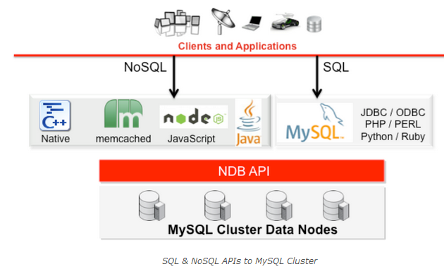

* Nosql: Nosql database is really important in growing industry use in big data application. Most social media websites such as Facebook, Twitter are using big data now. As mentioned before, employee communication page is created familiar with popular social media website. For adapting new technology, this project will contain Nosql database as well only for store the information of employee communication page. Consider the situation of this project requires stable loading and file storage functions, this project is going to be running on MongoDB.
* Bootstrap  
  As JavaScript extension, bootstrap contains HTML and CSS designed templates. It could compatible most major browsers, and supports responsive design. Adapt bootstrap could provide adjust page layout especially when using tablet and mobile phone. Therefore, it uses bootstrap as front-end framework.
* Less  
  Bootstrap consists a series of Less style sheets. Less is CSS style sheet language, and can provide variables, nesting, mixins, operators and functions. In this project, Less is necessary style sheet language.
* jQuery  
  jQuery's architecture allows developers to create plug-in code to extend its functionality. jQuery library allows the creation of powerful dynamic web pages and web applications. It is really helpful when creating waterfall styled employee communication page.
* Waterfall layout page (Innovation)  
  There is a personal innovation idea which is employee communication page adapts popular social media website layout-waterfall layout.

Social media website is popular now, and everyone get addiction to it. This communication page allows employees to share their ideas of work, interesting pictures or videos. In the other hand, it brings in the new technology as well-Nosql. The whole data of this communication page stores in this Nosql database. In addition, it provides a platform to let employees know each other and share information such as new technology, or useful resource.  
  
There is some open source has been found in JQuery, which is a most popular JavaScript library. A lot of website is using JQuery to work on their user interface design. Meanwhile, JQuery as a JavaScript library could compile well with php. For the record, Google+ and Facebook is typically waterfall layout page. The next picture is showing features of water fall layout page.

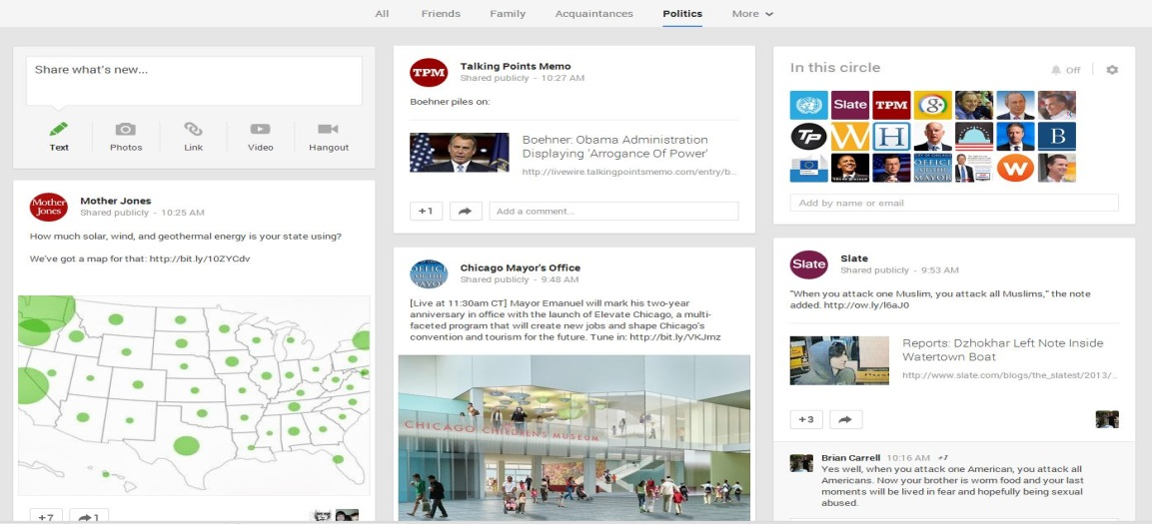

# **Scope and depth**

First, Office management system should be functional, and satisfy user’s requirement. System should be build based on functions of role diagram. In another word, system should accomplish Employee Maintain, Project Maintain, Customer Maintain, Generating Report, and Department Maintain.

Second, User interface should be clear and reliable. When a user login, could find all the information may need. If the office management system crash, office management system should be reliable to keep customer and employee information.

Because there are lot of personal information save in database, this system should be safety. At last, only authorized employee has right to work employee and customer’s information.

# **Test Case**

This test plan ensures the entire functional requirement is met. Based on functions of office management system, Test plan should focus on 4 major functions, which are employee maintain, customer maintain, project maintain and generate report.

* Test Employee Maintain function

|  |
| --- |
| T01 verify create new user function |
| Test: create new user button clickable or not  information inserted or not  new user created or not |
| Pass: the button clickable and new user could created |
| Fail: 1. create button not clickable  2. couldn't insert information  3 .couldn’t find created new user |
| T02 verify user login |
| Test: user could login or not |
| Pass: user enter Id and password and then login to personal page |
| Fail: 1.user enter Id and password couldn’t login/couldn’t go to personal page  2. user couldn’t enter any information |
| T03 verify employee update their personal information |
| Test: login as an employee and try to update information by click update |
| Pass: information updated |
| Fail: 1.function not clickable  2.information couldn’t insert  3.information couldn’t updated |
| T04 verify employee insert their personal information |
| Test: login as an employee and try to insert information |
| Pass: information inserted |
| Fail: 1.information couldn’t insert  2.there is no insert option |
| T05 verify employee delete their personal information |
| Test: login as an employee and try to delete information |
| Pass: information deleted |
| Fail: 1.information couldn’t deleted  2.there is no deleted option |
| T06 verify employee filling in check list function |
| Test: fill in a check list on employee’s webpage |
| Pass: fill in check list successfully |
| Fail: 1.couldn’t find this function on website  2.Information failed to insert |
| T07 verify function of post information on communication page |
| Test: user post any information(text/picture/video) on communication page |
| Pass: user can login and post text/picture/video on communication page |
| Fail: 1. there is no posted information function  2. couldn't fine posted inform  3. couldn’t load posted text/picture/video |
| T08 verify function of comment other’s post |
| Test: user login and comment other users post |
| Pass: there is comment beside the original post |
| Fail: 1. couldn’t fine comment  2.couldn’t make a comment |
| T09 verify function add a new employee |
| Test: login as administer, add a new employee to system |
| Pass: employee added successfully |
| Fail: 1.employee couldn’t added  2.couldn’t login at all  3. there is no such function |
| T10 verify function of delete employee |
| Test: login as administer, delete an employee |
| Pass: employee inform deleted successfully |
| Fail: 1. employee couldn’t deleted  2. couldn’t login  3. there is no delete function |

* Test Customer maintain function

|  |
| --- |
| T11 verify customer information delete, update, and insert |
| Test: login as administrator and insert, update and delete information |
| Pass: information could insert, delete, and update |
| Fail: 1. administrator couldn’t login   2. couldn’t find customer’s information  3. information couldn’t insert,  4. information couldn’t delete,  5. information couldn’t update |

|  |
| --- |
| T12 verify customer select function |
| Test: login as administrator and select a customer |
| Pass: after login, insert related information such as name, ID, or etc. |
| Fail: 1. couldn’t login  2. couldn’t find information  3. couldn’t insert inform |

* Test Project maintain function

|  |
| --- |
| T13 verify team leader login |
| Test: test team leader could login or not |
| Pass: team leader could login |
| Fail: 1.team leader couldn't login  2. there is no clickable login function at all  3. couldn’t insert information |
| T14 verify assign project function |
| Test: login as admin and assign a project to himself |
| Pass: project assigned successfully |
| Fail: 1. project couldn’t assigned  2. there is no assign function |
| T15 verify divide project function |
| Test: after login and assign the project, which should be divided into tasks |
| Pass: project could be divided |
| Fail: 1. There is no assigned project  2. there is no divide function  3. couldn’t divided the project |
| T016 verify arrange tasks to employee |
| Test: a team leader to pick his team members and assign them to each divided task |
| Pass: all the tasks has team member to work on and each team member has at least one task |
| Fail: 1. some task does not have team member to work  2. couldn’t pick team member  3. couldn't assign to team members |
| T17 verify generating check list function |
| Test: team leader to create check list to each team member based on member’s tasks |
| Pass: there is check list waits for each team member to fill in |
| Fail: 1. there is no check list at all  2. couldn’t find tasks  3. some team members doesn't has check list |

* Test report generate function

|  |
| --- |
| T18 verify generate report function |
| Test: set calendar time to the report sending time, and check system generate repot function |
| Pass: system gather check list and report generate successfully |
| Fail : 1. there is no report  2. system couldn’t gather check list information  2. system fail to generate report |
| T19 check the generate report with task status |
| Test: check the detail of report and compare to the tasks status |
| Pass: if report matches tasks status, it is pass |
| Fail: 1. report and task status does not match  2. there is no report |
| T20 verify report sending status |
| Test: login as team leader and check the report send or not |
| Pass: report send already |
| Fail: 1. report did not send  2. there is no report |

# **Time Estimates**

Because office management system adapts prototype as methodology, time estimate should follow its steps. Below are schedule delivery and summary estimates for all the features of the system.

|  |  |
| --- | --- |
| **Components** | **Effort(hours)** |
| **1.Identify basic functional requirement** | |
| Decide employee maintain, customer maintain, project maintain, department maintain, and generate report functions requirement | 5 |
| **2. Develop initial prototype** | |
| Based on the functional requirement to create initial prototype | 45 |
| Enhance prototype page | 20 |
| **3.System design** | |
| Website design/review | 20 |
| Develop RDBMS | 50 |
| Develop Nosql database | 45 |
| Develop employee maintain function | 40 |
| Water fall layout design | 20 |
| Develop customer maintain function | 15 |
| Develop project maintain function | 30 |
| Develop department maintain function | 10 |
| Develop generate report function | 35 |
| Database connection | 50 |
| Enhance User Interface design | 20 |
| **4. Test** | |
| Test and debug | 30 |
| **5.Final report** | |
| Documentation | 60 |
| **Total efforts** | **495** |

# **Appendix**

Login mock-up

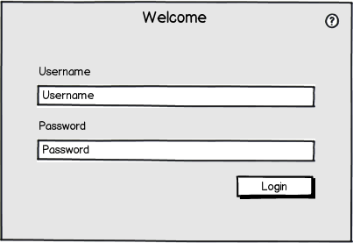

Personal page mock-up

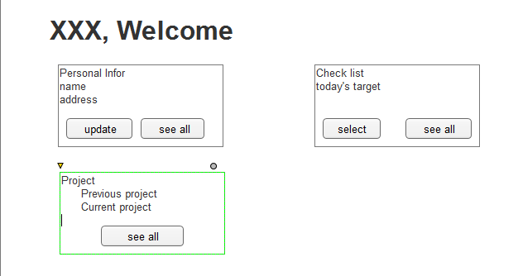

Communication page mock-up



# Change Log

1. Add Nosql database design section to expand technical complexity on page 12
2. Add Technical complexity Enhancement and New Leading edge Technology on page 13 to further discuss technical complexity and the conducted new technologies
3. Expand test plan from page 17 to 19.
4. Change time estimate on page 20.
5. Add a communication page mock-up on page 22.
6. Format table of content and page number